BASAVESHWAR ENGINEERING COLLEGE (Autonomous),

BAGALKOTE-587102



Department of electronics and communications

Certificate

This is to certify that project entitled “**UNIT CONVERTOR USING PYTHON**” a bonafied work of**, Miss.Suprita Biradar[2BA21EC112], Miss.Sushma Aski**[**2BA21EC113**]. The report satisfies the academic requirements with respect to project work prescribed for 3th semester during the academic year 2022-2023. It is certified that all corrections/suggestions indicated assessement of the project have been satisfied.

PROJECT GUIDE : HEAD OF THE DEPARTMENT :

PROF.M.C.ARALIMARAD DR.SHRIDHAR KUNTOJI

SIGNATURE WITH DATE :

INTRODUCTION

A unit **conversion expresses the same property as a different unit of measurement. For instance, currency can be expressed in** dollars instead of pound Or rupees, while distance can be **converted from centimeters to inches or feet, or any other measure of length, and temperature expressed in Fahrenheit instead of celsius.**

Often measurements are given in one set of units, such as feet, but are needed in different units, such as chains. A conversion factor is a numeric expression that enables feet to be changed to chains as an equal exchange.

A conversion factor is a number used to change one set of units to another, by multiplying or dividing. When a conversion is necessary, the appropriate conversion factor to an equal value must be used.

For example,

* To convertcentimeter into inches and feet, the appropriate conversion value is 100 centimeter is equal to3.37008 inches and 3 feet.
* To convert dollars to pounds appropriate conversion value is 1 pound equal to 1.21 US dollars .
* As same 1 degree celsius is equal to 33.8 degrees Fahrenheit.

A unit cancellation table is developed by using known units, conversion factors, and the fact that a unit of measure ÷ the same unit of measure cancels out that unit. The table is set up so all the units -

Chart for Length Unit Conversions

|  |  |  |
| --- | --- | --- |
| S. No. | Unit | Conversion factor |
| 1 | 1 millimeter | 0.001 meter |
| 2 | 1 centimeter | 0.01 meter |
| 3 | 1 decimeter | 0.1 meter |
| 4 | 1 decameter | 10 meters |
| 5 | 1 hectometer | 100 meters |
| 6 | 1 kilometer | 1000 meters |
| 7 | 1 inch | 2.54 x 10-2 meters |
| 8 | 1 foot | 0.3048 meter / 12 inches |
| 9 | 1 yard | 0.9144 meter / 3 feet |
| 10 | 1 mile | 1.609344 kilometers / 1760 yards / 5280 f 63,360 inches / 1609.344 meters |
|  |  |  |
|  |  |  |

Building the Unit Converter :

we have divided the complete project code into segments for better understanding.

To understand the code, we will be following the steps shown below:

**Step 1:** We will start by importing the required libraries and modules.

**Step 2:** We will then define the functions necessary for the execution of the application.

**Step 3:** We will define the required dictionary and lists to store the data.

**Step 4:** We will then create the main window for the application.

**Step 5:** We will then add the widgets to the main window and apply the event trigger to them.

Let us understand these steps in detail.

### Importing the required libraries and modules

We will start by importing the necessary libraries and modules required for the project. For this project, we will use the Tkinter library that will provide the Graphical User Interface to the application.

The following snippet of code demonstrates the same:

**File: unitConverter.py**

1. # importing all widgets and modules from the tkinter library
2. from tkinter import *

BUILDING FOR TEMPRATURE CONVERTOR :

FORMULAS :

Fahrenheit = (Celsius * 1.8) + 32*Fahrenheit*=(*Celsius*∗1.8)+32

Celsius = (Fahrenheit - 32)/1.8*Celsius*=(*Fahrenheit*−32)/1.8

Write a Python program to convert temperature from Celcius to Fahrenheit. Take input from user.

**Code :**

celsius = float(input("Enter temperature in celsius: "))

fahrenheit = (celsius * 1.8) + 32

print(str(celsius )+ " degree Celsius is equal to " + str(fahrenheit )+ " degree Fahrenheit.")

**Output**

Enter temperature in celsius: 50

50.0 degree Celsius is equal to 122.0 degree Fahrenheit.

### Approach

The user inputs a Celsius temperature. The code applies the conversion formula of Fahrenheit from Celsius and displays the final output. The relationship between the Celsius scale and the Fahrenheit scale is given by :

Fahrenheit = (Celsius * 1.8) + 32

Write a Python program to convert temperature from Fahrenheit to Celcius. Take input from user.

**Code**

fahrenheit = float(input("Enter temperature in fahrenheit: "))

celsius = (fahrenheit - 32)/1.8

print(str(fahrenheit )+ " degree Fahrenheit is equal to " + str(celsius ) + " degree Celsius." )

**Output**

Enter temperature in fahrenheit: 50

50.0 degree Fahrenheit is equal to 10.0 degree Celsius.

### Approach

The user inputs a Fahrenheit temperature. The code applies the conversion formula of Celsius from Fahrenheit and displays the final output. The relationship between the Fahrenheit scale and the Celsius scale is given by :

Celsius = (Fahrenheit - 32)/1.8

BUILDING FOR CURRENCY CONVERTOR

Code :

**def** convert(self, from_currency, to_currency, amount):

initial_amount = amount

#first convert it into USD if it is not in USD.

# because our base currency is USD

**if** from_currency != 'USD' :

amount = amount / self.currencies[from_currency

# limiting the precision to 4 decimal places

amount = round(amount * self.currencies[to_currency

**Example:**

url = 'https://api.exchangerate-api.com/v4/latest/USD'

converter = RealTimeCurrencyConverter(url)

print(converter.convert('INR','USD',100))

**OUTPUT:**  1.33

100 Indian rupees = 1.33 US dollars

PROGRAM FOR UNIT CONVERTOR :

def convert_temperature():

print("\nWhich conversion do you want to choose:-")

print("1. Celsius to Faranheit")

print("2. Faranheit to Celsius")

choice = int(input("Enter your choice: "))

if choice == 1:

temp = float(input("Enter temperature in celsius: "))

print(f"{temp} degree celsius is equal to {(temp*9/5)+32} degree faranheit.\n")

elif choice == 2:

temp = float(input("Enter temperature in faranheit: "))

print(f"{temp} degree faranheit is equal to {(temp-32)*5/9} degree celsius.\n")

else:

print("Invalid input...please try again\n")

def convert_currency():

print("\nWhich conversion do you want to choose:-")

print("1. Dollar to pound")

print("2. Pound to Dollar")

choice = int(input("Enter your choice: "))

if choice == 1:

value = float(input("Enter currency in dollars: "))

print(f"{value} dollars in pounds will be {value*0.73}\n")

elif choice == 2:

value = float(input("Enter currency in pounds: "))

print(f"{value} pounds in dollars will be {value/0.73}\n")

def convert_lengths():

print("\nWhich conversion do you want to choose:-")

print("1. Centimeters to foot and inches")

print("2. Foot and inches to centimeter")

choice = int(input("Enter your choice: "))

if choice == 1:

value = float(input("Enter length in cm: "))

inches = value/2.54

feet = inches/12

print(f"{value} centimeters in equal to {feet} feet and {inches} inch\n")

elif choice == 2:

feet = float(input("Enter length in feet: "))

inches = float(input("Enter length in inches: "))

length = (feet*12 + inches)*2.54

print(f"{feet} feet and {inches} inches in centimeters will be {length}\n")

print("===== Welcome to Value Converter =====")

while 1:

print("Which option would you like to choose:-")

print("1. Convert temperature")

print("2. Convert currency")

print("3. Convert lengths")

print("4. Exit")

choice = int(input("Enter your choice: "))

if choice == 1:

convert_temperature()

elif choice == 2:

convert_currency()

elif choice == 3:

convert_lengths()

elif choice == 4:

print('Exiting...')

exit(0)

OUTPUT :   
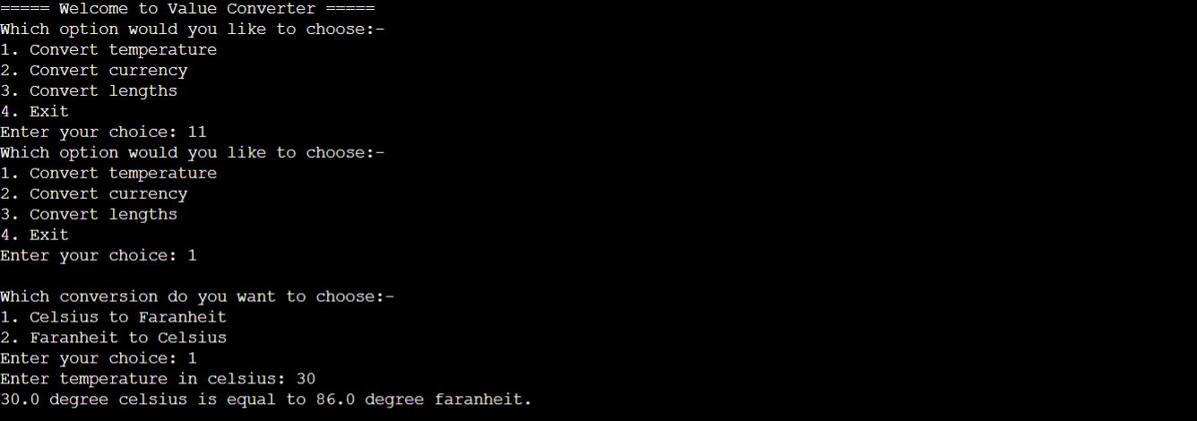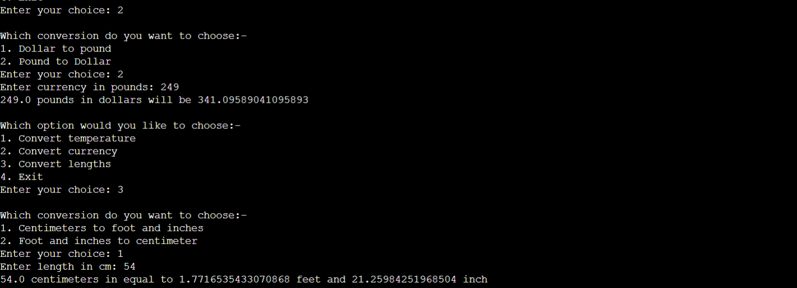

CONCLUSION :

In the above program we learnt about different standard units and their conversions using the different libraries in python. We imported different libraries and modules. We defined required dictionary and lists to store the data and functions necessary for the execution of the application.